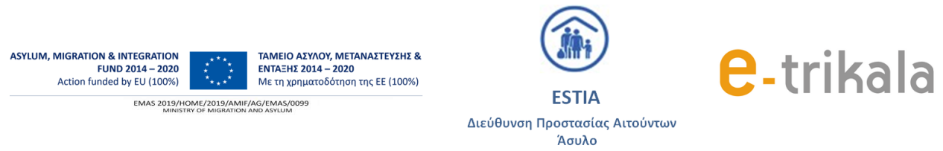

Trikala, 15/09/2021
INVITATION FOR EXPRESSION OF INTEREST
for the recruitment of staff with a fixed-term employment contract
.
The Development Municipal Company of the city of Trikala. (e-Trikala SA), in the context of the implementation of the Operation Action with code MIS (OPS) 5085302 entitled "ESTIA 2021: Accommodation program in the Municipality of Trikala for applicants for international protection" that has as implementing body the Reception and Identification Service of the General Secretariat of Applicants Ministry of Immigration and Asylum and is funded from the Asylum, Immigration and Integration Fund of the European Union, intends to hire staff to meet the needs of the project which is to create temporary accommodation in Trikala for asylum seekers and recognized refugees / refugees accommodated in the city of Trikala or in nearby settlements. The beneficiaries are provided with complete support by specialized staff, which is hired as part of the project. Under the above data, e-Trikala A.E. intends to hire specialized staff until 31/12/2021 with the possibility of extension
- Job positions
ΘΕ1 | Interpreter of Κurdish Kurmanji
ΘΕ2 | Interpreter of Kurdish Sorani

- Job Description
INTERPRETERS OF KURDS - Kurmanji & Sorani
- Supports the project team in communicating with the beneficiaries, transferring with the greatest possible accuracy the content and style of the oral conversations. He or she should be available at any time to meet any need
- Collaborates patiently and respectfully with the beneficiaries to ensure that there is proper communication and that the beneficiaries fully understand all discussions and procedures.

2. RECRUITMENT QUALIFICATIONS
2.1. FORMAL QUALIFICATIONS
Degree or diploma in Translation and Interpretation or in Translation or Interpretation or with a specialization in Translation or with a specialization in Interpreting in the Kurdish language from domestic universities and equivalent of foreign schools.
Or
Any degree or diploma from a University or diploma from the Hellenic Open University (EAP) or an Elective Program (P.S.E.) from a domestic University or other equivalent foreign title regardless of specialty and a certificate of Kurdish language proficiency (at least Level B2).
In case the position is not filled by the candidates who meet the above formal qualifications, candidates with mother tongue Kurdish Kurmanji & Sorani will be selected. In any case, candidates must have a good knowledge of Greek or English.
2.2. ADDITIONAL DESIRABLE QUALIFICATIONS
Driver license
Certificate of good knowledge of English

3. SUPPORTING DOCUMENTS
1. Application for expression of interest (available at the Company's offices or electronically available on the Company's website.)
2. Photocopy of Police ID card or critical pages of the passport (ie those where the number and identity details of the holder are mentioned) or a relevant temporary certificate from a competent Authority
3. Photocopy of residence permit in Greece with full access to the labor market (full market).
4. Photocopy of a certificate of good knowledge of English

4. APPLICATION PROCEDURE
Those who wish to submit the application can come daily (Monday to Friday) from 16/09/21 to 24/09/21, with the participation documents and submit the application to the following address:

E-TRIKALA A.E. ( EKE)
Κalampakas 28 & Αmpati
Τ.Κ.42100 - ΤRIKALA

5. SELECTION PROCEDURE

1. Receipt of applications and participation documents from e-Trikala A.E.
2. 1st phase of evaluation - Examination of the files of the beneficiaries by the Evaluation Committee and rejection of those who do not meet the minimum requirements.
3. Phase 2 evaluation - Personal interviews with those who meet the minimum requirements
4. Evaluation report, with grading
5. Notification of the minutes to the Board. of the Company for decision making

